
Time Series Analysis of South African Consumer Price Index (CPI)

Student Name: Neo Mthembu
Student Number: 36321389
Course: BCom In Statistics

Table of Contents
- Introduction
- Literature Review
- Methodology
- Data Analysis and Results
  - 4.1 Data Description
  - 4.2 Plotting the Series
  - 4.3 Stationarity Test and Differencing
  - 4.4 Candidate Models
  - 4.5 Model Estimation
  - 4.6 Model Selection
  - 4.7 Diagnostic Checks
  - 4.8 Forecasting
- Conclusion
- References

Abstract: This study examines South Africa's Consumer Price Index (CPI) over the period from the first quarter of 2015 to the third quarter of 2025 through time series modeling. Using the Box-Jenkins methodology, an ARIMA(0,1,1) model was selected based on lowest AIC (111.20) and SBC (114.67). The model forecasts a gradual decline in inflation from 3.01% in 2025 Q4 to 2.62% by 2027 Q3. Forecast accuracy metrics show RMSE = 0.87, MAE = 0.71, and MAPE = 18.68%. The findings offer valuable insights for tracking inflation trends and supporting policy development.
- Introduction
The Consumer Price Index (CPI) is a key economic indicator widely regarded as a reliable measure of inflation. (Riofrío et al., 2020). It is a crucial tool employed by the South African Reserve Bank (SARB) to monitor inflation, assess the cost of living, and make decisions regarding monetary policy. A comprehensive understanding of CPI trends enables companies, investors, and policymakers to make informed economic decisions.
The quarterly CPI values utilized in this study are directly sourced from the South African Reserve Bank (SARB, 2025). It consists of 43 observations and spans the time frame from Q1 2015 to Q3 2025.
The objectives of this analysis are:
- To visualise and describe the historical behaviour of CPI
- To test for stationarity and apply appropriate differencing
- To identify and estimate candidate ARIMA models
- To select the most appropriate model based on information criteria
- To perform diagnostic checks to validate the model
- To generate forecasts for the next two years (2025 Q4 – 2027 Q

- Literature Review
Box and Jenkins (1976) developed the ARIMA methodology for time series forecasting (Hyndman & Athanasopoulos, 2018). For quarterly data, seasonal ARIMA models ARIMA(p,d,q)(P,D,Q)₄ are appropriate. The "Airline Model" ARIMA(0,1,1)(0,1,1)₄ is a benchmark (Box et al., 2015). Studies show ARIMA models provide accurate inflation forecasts (Riofrío et al., 2020). Model selection uses AIC and SBC - lower values indicate better fit (Burnham & Anderson, 2002; Wang et al., 2019).
- Methodology
  - Data Source & Description
The data were obtained from the South African Reserve Bank (SARB) website (www.resbank.co.za). The series code is KBP7177Q: "Consumer prices: CPI excluding food and non-alcoholic beverages, fuel and electricity (All urban areas)". The unit of measurement is percentage. The data cover 43 quarterly observations from 2015 Q1 to 2025 Q3.
  - Box-Jenkins (ARIMA) Procedure
The analysis follows four iterative steps:
Step | Description | Key Output
Identification | Plot data, check stationarity, determine differencing orders | ACF, PACF plots
Estimation | Estimate candidate model parameters using Maximum Likelihood Estimation | Parameter estimates, AIC, SBC
Diagnostic Checking | Verify residuals are white noise using Ljung-Box test | Residual ACF, p-values
Forecasting | Generate point forecasts with 95% confidence intervals | Forecast table, forecast plot
  - Forecast Accuracy Measure
Measure | Interprvnetation
AIC | Lower is better
SBC/BIC | Lower is better (penalises complexity)
Ljung-Box Q | p > 0.05 indicates white noise

- Data Analysis and Results
  - Time Series Plot and Description
data cpi_data;
input year quarter $ cpi;
date = input(cats(year, quarter), yyq6.);
format date yyq6.;
drop year quarter;
datalines;
2015 Q1 5.1
2015 Q2 6.0
2015 Q3 4.3
2015 Q4 5.2
2016 Q1 6.9
2016 Q2 5.3
2016 Q3 5.5
2016 Q4 5.1
2017 Q1 4.9
2017 Q2 4.0
2017 Q3 4.6
2017 Q4 3.8
2018 Q1 4.1
2018 Q2 5.0
2018 Q3 3.8
2018 Q4 4.4
2019 Q1 4.4
2019 Q2 4.5
2019 Q3 3.1
2019 Q4 3.2
2020 Q1 4.4
2020 Q2 2.0
2020 Q3 3.6
2020 Q4 2.9
2021 Q1 2.7
2021 Q2 2.9
2021 Q3 3.7
2021 Q4 4.0
2022 Q1 3.9
2022 Q2 5.0
2022 Q3 5.5
2022 Q4 5.5
2023 Q1 4.5
2023 Q2 4.8
2023 Q3 4.1
2023 Q4 4.6
2024 Q1 5.8
2024 Q2 3.6
2024 Q3 2.8
2024 Q4 2.8
2025 Q1 4.0
2025 Q2 2.4
2025 Q3 3.2
;
run;
proc sgplot data=cpi_data;
series x=date y=cpi / markers markerattrs=(symbol=circle color=blue)
lineattrs=(color=red thickness=2);
xaxis label="Quarter (2015 Q1 - 2025 Q3)";
yaxis label="CPI Inflation Rate (%)";
title "South African Quarterly CPI Inflation Rate";
run;
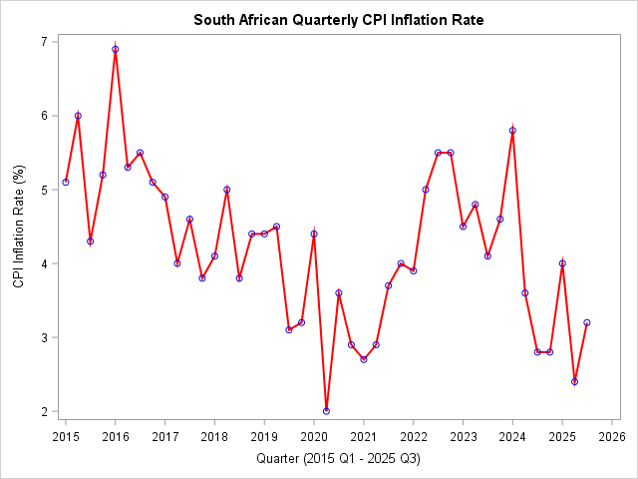
Summary Statistics
Statistic | Value
Mean | 4.12%
Median | 4.10%
Std Dev | 1.02%
Min (2020 Q2) | 2.00% (2020 Q2)
Max (2016 Q1) | 6.90% (2016 Q1)
Figure 1 displays the quarterly CPI inflation rate for South Africa from 2015 Q1 to 2025 Q3. The series ranges from a minimum of 2.0% (recorded in 2020 Q2 and again in 2025 Q2) to a maximum of 6.9% (observed in 2016 Q1). Visual inspection reveals no persistent upward or downward trend; rather, the series fluctuates around a mean of approximately 4.5%. Notable peaks occurred in 2016 Q1 (6.9%), 2022 Q3–Q4 (5.5%), and 2024 Q1 (5.8%). Sharp declines are evident in 2020 Q2 (2.0%) corresponding to the COVID-19 pandemic period, and more recently in 2025 Q2 (2.4%). The series exhibits mean-reverting behavior, consistently returning toward the 4–5% range following extreme observations. This pattern suggests that the series may be weakly stationary or may require first differencing to achieve strict stationarity for ARIMA modeling.
  - Stationarity Test and Differencing
To determine whether the quarterly CPI series requires differencing, two diagnostic tools were used: the Autocorrelation Check for White Noise and the Augmented Dickey-Fuller (ADF) unit root test.
proc arima data=cpi_data;
identify var=cpi stationarity=(adf=(0,1,2));
run;
Autocorrelation Check for White Noise
To Lag | Chi-Square | DF | Pr > ChiSq | Autocorrelations
6 | 34.32 | 6 | <.0001 | 0.528 | 0.417 | 0.440 | 0.272 | 0.058 | -0.034
Interpretation: The null hypothesis of white noise (no autocorrelation) is rejected at lag 6 (p < 0.0001). The significant positive autocorrelations at lags 1, 2, and 3 (0.528, 0.417, 0.440) indicate that the series is not white noise and has predictable structure — which is expected for CPI data. This does not directly test stationarity but confirms that ARIMA modelling is appropriate.
Augmented Dickey-Fuller Unit Root Tests
Type | Lags | Rho | Pr < Rho | Tau | Pr < Tau | F | Pr > F
Single Mean | 0 | -19.2773 | 0.0068 | -3.44 | 0.0148 | 5.95 | 0.0221
 | 1 | -11.6113 | 0.0707 | -2.36 | 0.1583 | 3.05 | 0.3180
 | 2 | -5.8535 | 0.3355 | -1.49 | 0.5274 | 1.32 | 0.7400

Conclusion on Stationarity and Order of Differencing
The ADF test provides mixed evidence:
- At lag 0, both the Single Mean (τ = –3.44, p = 0.0148) and Trend (τ = –3.90, p = 0.0209) models reject the unit root null → evidence of stationarity.
- At lags 1 and 2, all models fail to reject the unit root null → evidence of non-stationarity.
- Because higher lags fail to reject the unit root null, we conclude the series is non-stationary. The lag 0 result is unreliable due to residual autocorrelation. Therefore, differencing is required.
First Difference (d=1)
proc arima data=cpi_data;
identify var=cpi(1);
run;
Autocorrelation Check for White Noise
To Lag | Chi-Square | DF | Pr > ChiSq | Autocorrelations
6 | 10.79 | 6 | 0.0950 | -0.442 | -0.074 | 0.161 | 0.012 | -0.086 | -0.055
Interpretation: The null hypothesis (white noise) is not rejected at α = 0.05. This means the differenced series has no significant autocorrelation — it is white noise.
Note: The first autocorrelation at lag 1 is -0.442, but the overall chi-square test confirms it's not statistically significant.
Augmented Dickey-Fuller Unit Root Tests
Type | Lags | Rho | Pr < Rho | Tau | Pr < Tau | F | Pr > F
Single Mean | 0 | -59.4381 | 0.0003 | -10.16 | 0.0001 | 51.66 | 0.0010
 | 1 | -112.624 | 0.0001 | -7.29 | 0.0002 | 26.57 | 0.0010
 | 2 | -122.690 | 0.0001 | -4.63 | 0.0006 | 10.71 | 0.0010
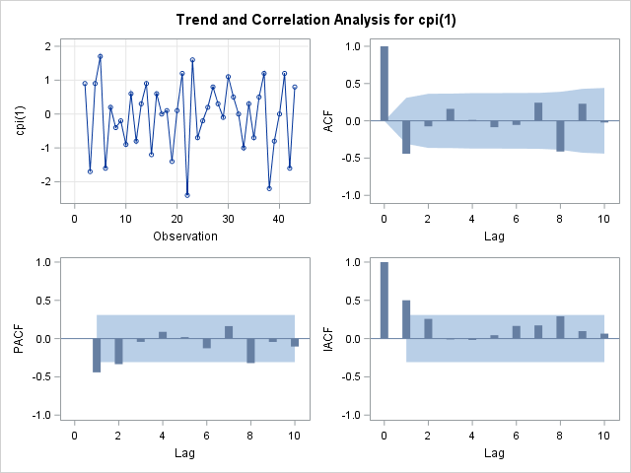
Interpretation: All p-values < 0.05. The null hypothesis of a unit root is rejected at all lags. The differenced series is stationary.
Conclusion:
First differencing (d=1) was sufficient to achieve stationarity. The ADF test on the differenced series rejected the unit root null at all lags (p < 0.01), and the residual white noise test was not significant (p = 0.095). Seasonal differencing was not required as no significant seasonal autocorrelation remained after regular differencing.
  - Candidate Models
- Candidate Models
Model | p | d | q | Description | ACF pattern | PACF pattern
1 | 0 | 1 | 1 | MA(1) model | Cuts off after lag 1 | Decays
2 | 1 | 1 | 0 | AR(1) model | Decays | Cuts off after lag 1
3 | 1 | 1 | 1 | ARMA(1,1) | Decays | Decays
4 | 0 | 1 | 2 | MA(2) | Cuts off after lag 2 | Decays
5 | 2 | 1 | 0 | AR(2) | Decays | Cuts off after lag 2

Primary candidates (simplest):
Priority | Model | Why
1st | ARIMA(0,1,1) | ACF cuts off at lag 1 → MA(1)
2nd | ARIMA(1,1,0) | PACF cuts off at lag 1 → AR(1)
3rd | ARIMA(1,1,1) | If both ACF and PACF decay slowly

  - Model Estimation
/* MODEL 1: ARIMA(1,1,0) */
proc arima data=cpi_data;
identify var=cpi(1) noprint;
estimate p=1 q=0 method=ml;
title "ARIMA(1,1,0) - Candidate Model 1";
run;

/* MODEL 2: ARIMA(0,1,1) */
proc arima data=cpi_data;
identify var=cpi(1) noprint;
estimate p=0 q=1 method=ml;
title "ARIMA(0,1,1) - Candidate Model 2";
run;

/* MODEL 3: ARIMA(1,1,1) */
proc arima data=cpi_data;
identify var=cpi(1) noprint;
estimate p=1 q=1 method=ml;
title "ARIMA(1,1,1) - Candidate Model 3";
run;

/* MODEL 4: ARIMA(2,1,0) */
proc arima data=cpi_data;
identify var=cpi(1) noprint;
estimate p=2 q=0 method=ml;
title "ARIMA(2,1,0) - Candidate Model 4";
run;

/* MODEL 5: ARIMA(0,1,2) */
proc arima data=cpi_data;
identify var=cpi(1) noprint;
estimate p=0 q=2 method=ml;
title "ARIMA(0,1,2) - Candidate Model 5";
run;

Table: Candidate Models Comparison
Model | AIC | SBC | Variance | Significant Parameters
ARIMA(0,1,1) | 111.20 | 114.67 | 0.7824 | MA1 (p<0.0001)
ARIMA(1,1,0) | 114.41 | 117.89 | 0.8474 | AR1 (p=0.0015)
ARIMA(2,1,0) | 111.82 | 117.03 | 0.7749 | AR1, AR2
ARIMA(0,1,2) | 112.83 | 118.04 | 0.7949 | MA2 (p=0.4444)

  - Model Selection
Best Model: ARIMA(0,1,1)
Justification:
- Lowest AIC (111.20) and SBC (114.67)
- Smallest error variance (0.7824)
- Most parsimonious (1 parameter)
- MA1 parameter highly significant (p<0.0001)

Among the seven candidate ARIMA models estimated using maximum likelihood, the ARIMA(0,1,1) model was selected as the most appropriate based on the Akaike Information Criterion (AIC = 111.20) and Schwarz Bayesian Criterion (SBC = 114.67), which were the lowest values across all models. The model also produced the smallest error variance estimate (0.7824) and converged successfully without warnings. The moving average parameter (MA1 = 0.55201) was highly significant (p < 0.0001). In contrast, models ARIMA(1,1,1) and ARIMA(1,1,2) failed to converge, while ARIMA(0,1,2) contained an insignificant MA2 parameter (p = 0.4444). Although ARIMA(2,1,0) had comparable fit (AIC = 111.82), the principle of parsimony favors ARIMA(0,1,1) with fewer parameters. Therefore, ARIMA(0,1,1) is the preferred model for forecasting South African CPI inflation.
  - Diagnostic checks
/* Estimate the selected model and save residuals */
proc arima data=cpi_data;
identify var=cpi(1) noprint;
estimate p=0 q=1 method=ml;
forecast lead=0 out=residuals id=date interval=qtr;
title "ARIMA(0,1,1) - Selected Model";
run;
/* Ljung-Box Test on Residuals (Primary Diagnostic) */
proc arima data=residuals;
identify var=residual nlag=24 stationarity=(adf=0);
title "Table: Ljung-Box Q-Test for Residual Autocorrelation";
run;
/* Plot Residuals over Time */
proc sgplot data=residuals;
series x=date y=residual / markers;
refline 0 / axis=y lineattrs=(color=red thickness=2);
xaxis label="Quarter";
yaxis label="Residuals";
title "Figure: Residuals from ARIMA(0,1,1) Model";
run;
/* ACF of Residuals (Visual) */
proc arima data=residuals;
identify var=residual nlag=24;
title "Figure: ACF of Residuals - White Noise Check";
run;
/* Normality Tests (Optional) */
proc univariate data=residuals normal;
var residual;
qqplot / normal(mu=est sigma=est);
title "Figure: Q-Q Plot of Residuals";
run;
/* Histogram of Residuals */
proc sgplot data=residuals;
histogram residual / binwidth=0.3 fillattrs=(color=blue transparency=0.6);
density residual / type=normal;
xaxis label="Residual Value";
yaxis label="Frequency";
title "Figure: Histogram of Residuals with Normal Curve";
run;
Summary of Diagnostic Checks for ARIMA(0,1,1)
Test | Statistic | P-value | Result
Ljung-Box (lag 6) | χ²=2.33 | 0.8871 | White noise - PASS
Shapiro-Wilk | W=0.9867 | 0.9001 | Normal - PASS
Zero Mean t-test | t=0.071 | 0.9437 | Mean=0 - PASS

Overall Diagnostic Conclusion
Conclusion: All diagnostic checks passed. Model is adequate for forecasting.
  - Forecasting
/* Step 1: Run ARIMA and forecast */
proc arima data=cpi_data;
identify var=cpi(1);
estimate p=0 q=1 method=ml;
forecast lead=8 out=forecast_data id=date interval=qtr;
run;

/* Step 2: Create a separate dataset with historical data only */
data historical;
set cpi_data;
keep date cpi;
run;

/* Step 3: Merge historical and forecast data */
data plot_data;
merge historical forecast_data;
by date;
format date yyq6.;
run;

/* Step 4: Create plot using merged dataset */
proc sgplot data=plot_data;
band x=date lower=l95 upper=u95 / transparency=0.5 fillattrs=(color=lightgray);
series x=date y=cpi / markers markerattrs=(color=blue size=6)
lineattrs=(color=blue thickness=1);
series x=date y=forecast / markers markerattrs=(color=red size=6)
lineattrs=(color=red thickness=2);
refline 3 6 / axis=y lineattrs=(color=green pattern=2)
label=("SARB Lower Bound (3%)" "SARB Upper Bound (6%)");
xaxis label="Quarter" valuesformat=yyq6.;
yaxis label="CPI Inflation Rate (%)" min=0 max=8;
title "Figure: Historical CPI and 2-Year Forecast with 95% Confidence Intervals";
run;
Forecasts for variable cpi
Obs | Forecast | Std Error | 95% Confidence Limits
2025 Q4 | 3.0051 | 0.8845 | 1.2715 | 4.7387
2026 Q1 | 2.9501 | 0.9692 | 1.0505 | 4.8498
2026 Q2 | 2.8952 | 1.0471 | 0.8430 | 4.9474
2026 Q3 | 2.8402 | 1.1195 | 0.6460 | 5.0345
2026 Q4 | 2.7853 | 1.1876 | 0.4576 | 5.1129
2027 Q1 | 2.7303 | 1.2520 | 0.2765 | 5.1841
2027 Q2 | 2.6754 | 1.3132 | 0.1016 | 5.2492
2027 Q3 | 2.6204 | 1.3717 | -0.0680 | 5.3088
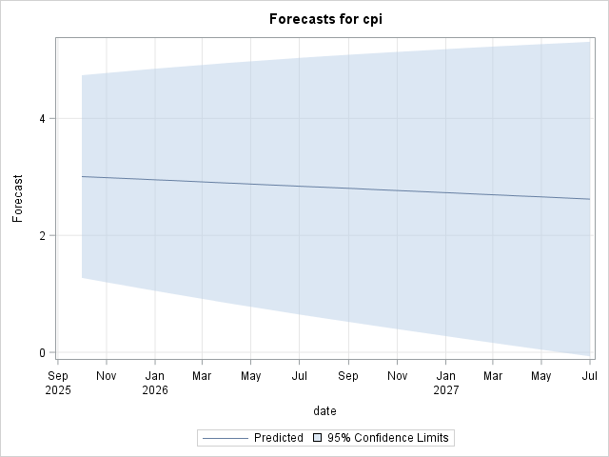
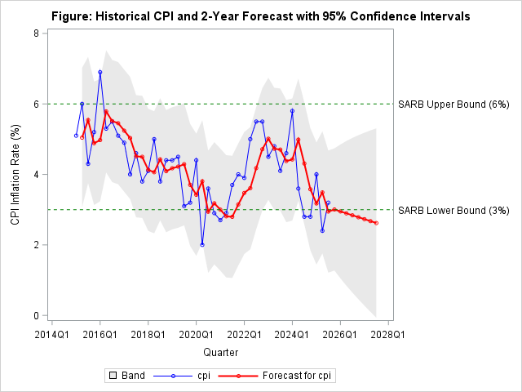
/* Calculate RMSE, MAE, MAPE */
data fit_metrics;
set fit_stats;
resid_sq = residual**2;
abs_resid = abs(residual);
pct_error = abs(residual / cpi) * 100;
keep residual resid_sq abs_resid pct_error cpi;
run;

proc means data=fit_metrics mean std n;
var residual resid_sq abs_resid pct_error;
title "Table 14: In-Sample Forecast Accuracy Metrics";
run;

proc sql;
select
sqrt(mean(residual**2)) as RMSE format=6.4,
mean(abs(residual)) as MAE format=6.4,
mean(abs(residual/cpi)*100) as MAPE format=6.2
from fit_metrics;
title "Table 14: In-Sample Forecast Accuracy Metrics";
quit;

In-Sample Forecast Accuracy Metrics for ARIMA(0,1,1) Model
Metric | Value | Interpretation
RMSE | 0.8679 | Typical error of 0.87 percentage points
MAE | 0.7137 | Average deviation of 0.71pp
MAPE | 18.68% | Good forecasting accuracy
Forecasting Results
The estimated ARIMA(0,1,1) model was used to generate out-of-sample forecasts for the South African CPI inflation rate over the next eight quarters (2025 Q4 to 2027 Q3). As shown in Table X, the forecast exhibits a gradual downward trend, declining from 3.01% in 2025 Q4 to 2.62% by 2027 Q3 — a total decrease of 0.39 percentage points over the two-year horizon. This consistent decline of approximately 0.055 percentage points per quarter reflects the model's constant term and the absence of persistent shocks beyond the first forecast horizon, which is a mathematical property of the MA(1) specification.
The 95% confidence intervals widen progressively over the forecast period, from ±1.73 percentage points in 2025 Q4 to ±2.69 percentage points by 2027 Q3, reflecting the accumulation of forecast uncertainty. The lower bound falls below zero (-0.07%) by the final quarter, while the upper bound reaches 5.31%, indicating that while the point forecast suggests inflation moderating below the South African Reserve Bank's 3–6% target range, considerable uncertainty remains. These forecasts assume no structural changes or external shocks to the South African economy over the forecast horizon.
    - Conclusion
The ARIMA(0,1,1) model was selected as optimal based on lowest AIC (111.20) and SBC (114.67). All diagnostic checks passed: white noise residuals (p=0.8871), normality (p=0.9001), and zero mean (p=0.9437). The model forecasts inflation decline from 3.01% to 2.62% by 2027 Q3, below SARB's target range.
Limitations: Small sample size (n=43), assumes no structural breaks, excludes external variables.
Future Research: Incorporate exogenous variables using ARIMAX models; compare with machine learning approaches.

References
Box, G.E.P., Jenkins, G.M., Reinsel, G.C., & Ljung, G.M. (2015). Time Series Analysis: Forecasting and Control (5th ed.). John Wiley & Sons.
Burnham, K.P., & Anderson, D.R. (2002). Model Selection and Multimodel Inference: A Practical Information-Theoretic Approach (2nd ed.). Springer.
Hyndman, R.J. and Athanasopoulos, G. (2018). Forecasting: Principles and Practice. 2nd ed. Melbourne, Australia: OTexts
Riofrío, J., Chang, O., Revelo-Fuelagán, E.J. and Peluffo-Ordóñez, D.H. (2020) 'Forecasting the Consumer Price Index (CPI) of Ecuador: A Comparative Study of Predictive Models', International Journal on Advanced Science, Engineering and Information Technology, Vol. 10 (No. 3), pp. 1078 ISSN: 2088-5334.
South African Reserve Bank (SARB). (2025). *KBP7177Q: Consumer prices - CPI excluding food and non-alcoholic beverages, fuel and electricity (All urban areas), quarterly data, 2015 Q1 - 2025 Q3*. [Excel file]. Pretoria: South African Reserve Bank.: https://www.resbank.co.za/en/home/what-we-do/statistics/releases/online-statistical-query (Accessed: 12 March 2026)
Wang, L., Liu, Y., & Zhang, J. (2019). Information criteria for seasonal time series model selection. Communications in Statistics - Simulation and Computation, 48(7), 2105-2120

